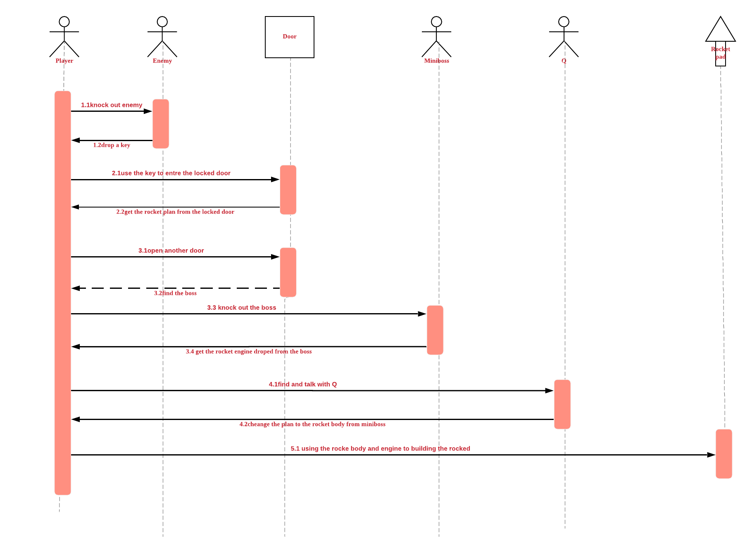

Explanation of interaction diagram

The diagram above shows us the process of this game, at first, there are two locked doors on the ground, player can not access without holding the key, the way to get key is knocking down the enemy and the key will be dropped from enemy randomly. After getting the key, we can access one of the locked doors and get the rocket plan. Then access the other door to find the mini-boss(3.2 we have to open the door and verify the boss)we also need to get the rocket engine by knocking it out. After these, by carrying the rocket plan, go to find the NPC Q, then talk to him, we will change our rocket plan to body, now we get everything of building the rocket, so the final step is to put body and engine on the rocket pad to complete this game.